|  |  |  |  |
| --- | --- | --- | --- |
| DATE: | February 20, 2020 | | |
| TO: | George Cotton |  |  |
| FROM: | Saul Ramirez | | |
| COPY: |  | | |
| SUBJECT: | RocKIE Riprap Gradation Algorithm | | |

**FOR IMMEDIATE DISTRIBUTION**

# Background:

I’m writing to report the status of RocKIE and explain the algorithm. The process takes two scripts, a Data Preprocessing script, and the actual data processing. The results from this script are to analyze individual riprap particles and approximate their primary, secondary, and vertical axis as well as approximate the particle volume.

# Preprocessing:

Preprocessing is done by the “DataImport.m” script. This process assumes that Lidar data has been manually segmented, and clusters representing individual particles have been grouped and given a unique identification. The input to the script must be a .csv file with 4 columns corresponding to Id, X, Y, and Z respectively and no headers.

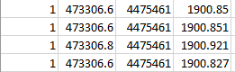

When the DataImport script runs, it will ask the user for the name of the .csv file they’d like to import. The .csv file must be in the same folder as the script in order to run it based off the name, otherwise, the user will have to input the entire file path in order to load the file.

The DataImport script consolidates the dataset into a Cell Structure in which every row contains all the data associated with the Rock Id organized as Id, X, Y, Z.

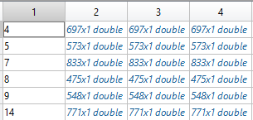

After the script runs, it will ask the user to give a name to the dataset and MATLAB will save the file as a .mat file.

# RocKIE Calculations:

## Two-Dimensional Analysis

The first step RocKIE does is clear the existing workspace and load the data. The user sets the ShrinkF, which is the shrink factor. ShrinkF used in Boundary function parameter, the value of 0.1 creates more points than using 0.0 This was the value that gave a boundary most representative of the hand-drawn boundaries.

The first group of code inside the outer loop will load the 3d point cloud and give the user a feel for the data. In the test situation we will analyze a half of a hypothetical ellipsoid with the dimensions: xr=10m, yr=5m, and zr=2m. The script will calculate the complete ellipsoid volume, and should be 418.87 m3, even though the volume of the visible data is 209.44 m3 .

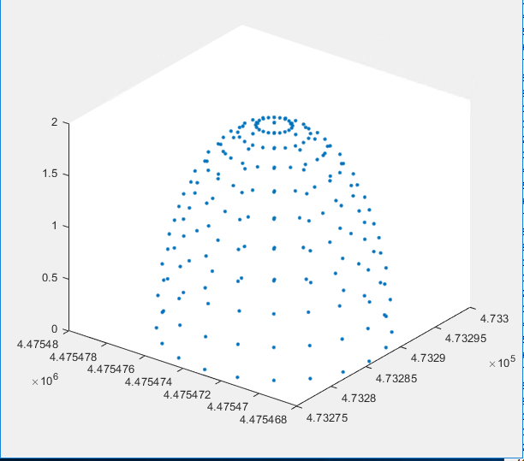

The next section obtains the 2-dimensional XY boundary. MATLAB compues this using a Convex Hull approach with a shrinking Alhpashape factor allowing the boundary to Shrink. The fit around can be adjusted by changing ShrinkF by default it is 0.5 and it is the best fit generally by trial and error. The boundary should appear as the plan-view boundary of the dataset. The boundary can drastically change if the ShrinkF value is changed up or down, or even if the boundary points are interpolated to obtain more data. The next step is to convert the boundary points into a polyshape object and calculate the centroid.

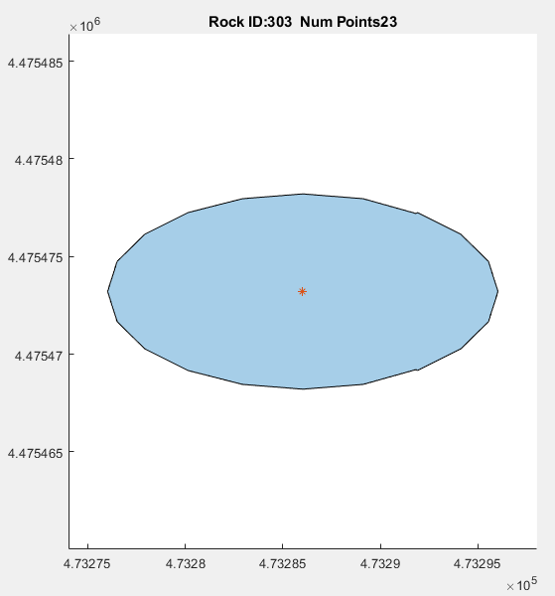

In order to calculate the Primary Axis, the RocKIE algorithm obtains the longest length within a rock by calculating the length from every point to every other point and selecting the largest path. Once the primary axis is found, the boundary dataset is rotated so that the primary axis is parallel to the X-axis and that Primary Axis Point 1 is always left of Primary Axis Point 2.

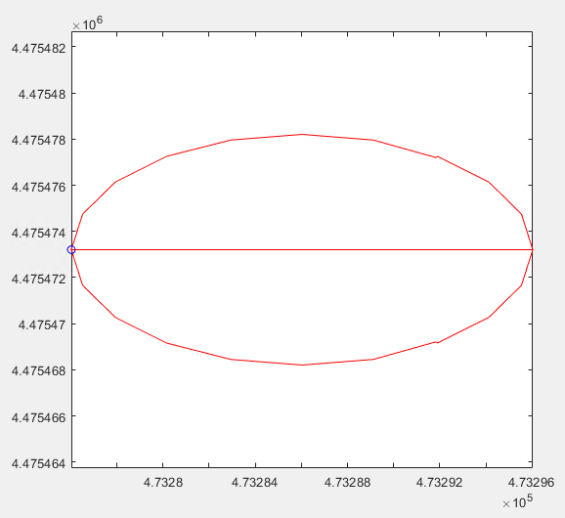

The secondary axis is found by applying a best fit line to the polyshape. The best fit line is a double weighted system where the algorithm searches for the line made of the two points that are the longest, most perpendicular to the primary axis and closest to the centroid.

|  |  |
| --- | --- |
| Factor | Weight |
| Dot Product, | 0.50 |
| Length, | 0.25 |
| Centroid, | 0.25 |
| Fit, | 1 |

A dot product divided by it’s normal will give the cosine angle between two vectors and by forcing it to be absolute, the answer will always be between 0 and 1. When the dot product divided by the norm is 0, the vectors are perpendicular.

Where

P1: The Principle Axis vector

Ps: The purposed Secondary Axis vector

Dot: Perpendicular factor, between 0 and 1 based on the unit circle

The length factor is calculated by the Pythagorean Theorem and divided by the Length of the primary axis to get a number between 0 and 1. Once the ratio is calculated, it is place in the logistic regression formula in order to get a number between 0.5 and 1.0. If the ratio is larger than 0.68, only 0.68 is factored into the weight. The logistic regression equation was chosen because the change is gradual and only gives slight logarithmic increase in weight to a linear increase in length.

Where

Lp: Length of Principle Axis vector

Ls: Length of purposed Secondary Axis vector

Lf: Perpendicular factor, between 0.5 and 0.65 based on the unit circle

The distance to the centroid is calculated using a distance norm between the Primary Axis, centroid, and proposed secondary axis.

Where

L2: Length of purposed Secondary Axis vector

dc: Distance from Secondary Axis vector to the Centroid

Cent: Centroid factor

The general fit equation is:

Once the algorithm loops through all the points looking for the best fit line and when it’s found, it plots it.

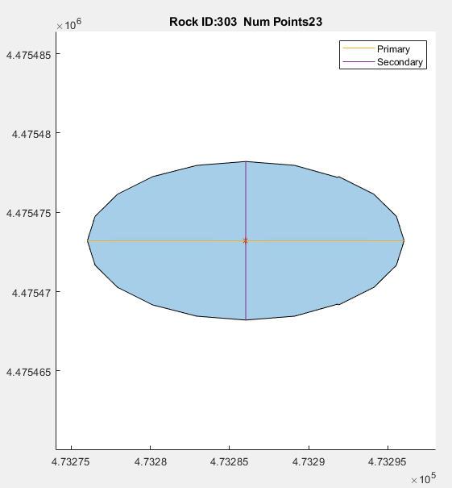

## Three-Dimensional Analysis and Grid Volume

In the volumetric analysis, we approximate the volume of the rock gridding the boundary with a minimum resolution of 1 cm2 (0.0001 m2) and creating a bottom and top surface. The bottom surface is interpolated from the two-dimensional boundary values using natural neighbor interpolation.

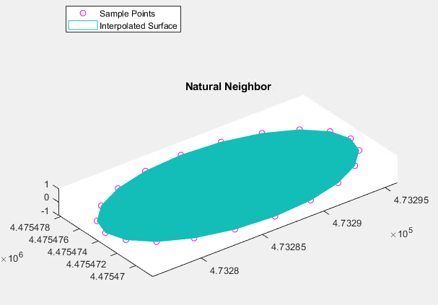

The Top Surface is approximated by using the same grid as the bottom surface and interpolating the sample points using natural neighbor and extrapolating linearly at edges in order to create most data.

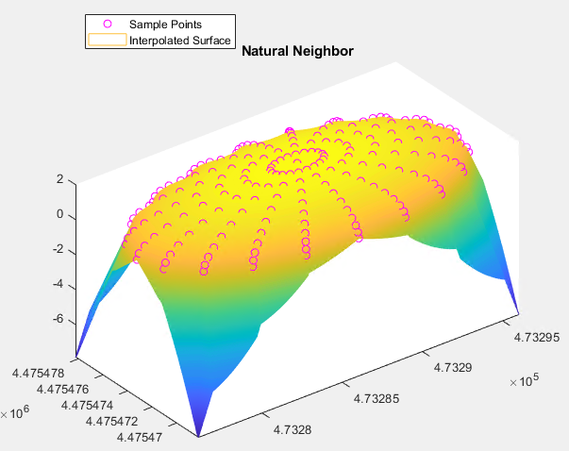

Once the two surfaces are created, they are intersected, and edges are cleaned and aligned. Once the surfaces are prepared, and the volume is calculated by subtracting the two surfaces and multiplying by the grid area, then adding the individual grid volumes. This approximates the volume as 198.77 m3 instead of 209.44 m3. This is a 5.09% error most likely introduced by the artificial boundary ridges and surface interpolation. Error could be reduced by increasing the point density and boundary interpolation.

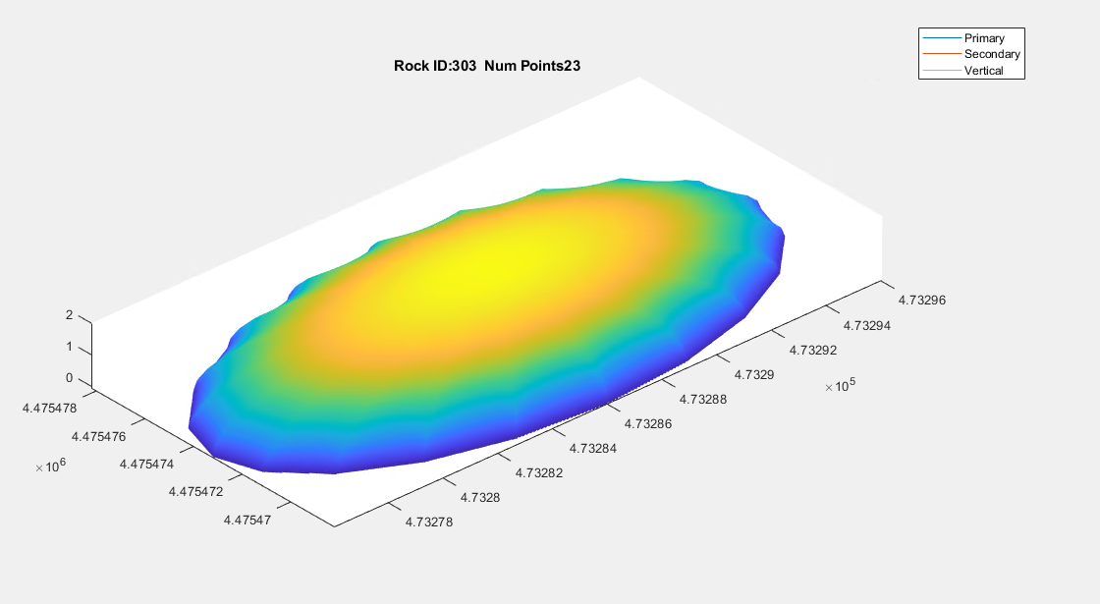

## Vertical axis and Ellipsoidal Volume

The vertical axis is calculated by finding the intercept of the primary and secondary axis. At this point the bottom and top surfaces are sampled at the point in order to assign an elevation boundary on both sides of the vector. The Ellipsoidal Volume is calculated by using the equation:

Calculating an ellipsoidal volume (EV) of 418.659 where the real volume was 418.879, equating a 0.053% error.

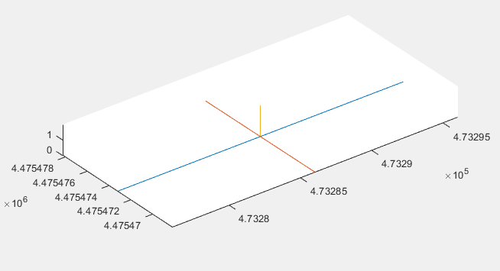

# Rockie Results:

The RocKIE algorithm works well, when there is a well segmented cluster of scatter points. A point cloud density for a well-defined rock is at least 500 points, but a using a minimum of 200 points per rock appears to give an acceptable surface mesh and geometry for calculations.

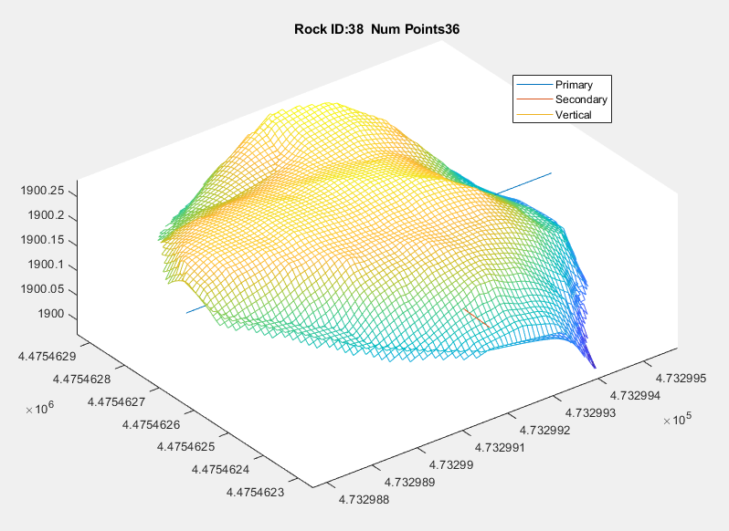

There are two fundamental flaws with this methodology, shown below. The first is that even when a stone has a point cloud density higher than 200 points, if the stone is covered and gives no boundary information, the rock will appear flat. Though this calculation is not unusable as the primary and secondary axis give insight to the general Length: Width ratio to determine if the rock is too skinny for energy dissipation. A check in the results gives a warning if a rocks Vertical axis is less than 5% of the Primary axis length. A better scan is required to obtain more data if the stone is in the open; if the stone is covered this will be the best analysis available.

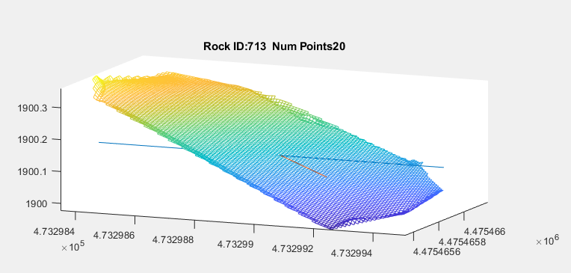

The second fundamental flaw originates in the manual delineation of the stone particles. Shown below is the underside of Rock 306, where the Primary and Secondary axis line up with what a reviewer would expect for the geometrical shape. When the particle is rotated, the Primary Axis goes through the void space and isn’t in fact the primary axis of the stone, but the primary axis of the manually segmented cluster. Since the Primary Axis isn’t correct, the Secondary and Vertical axis will be incorrect.

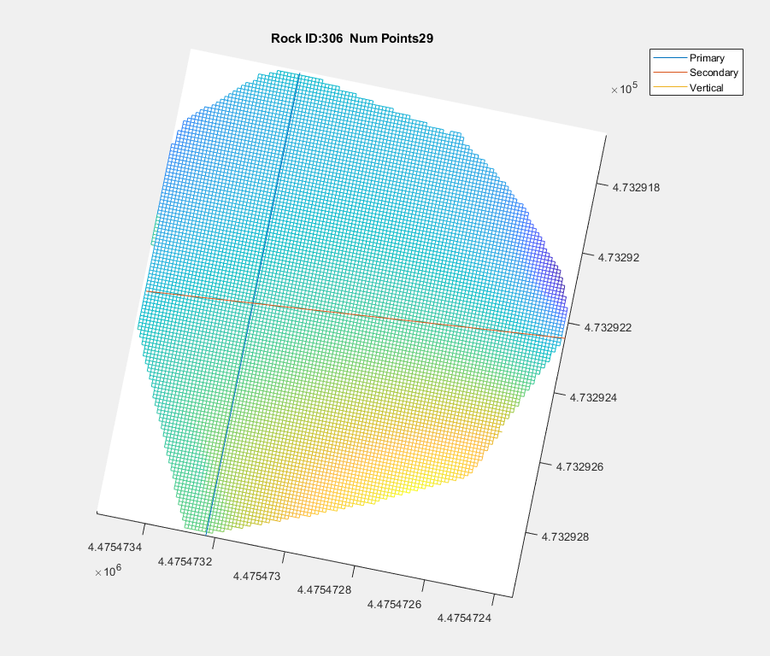

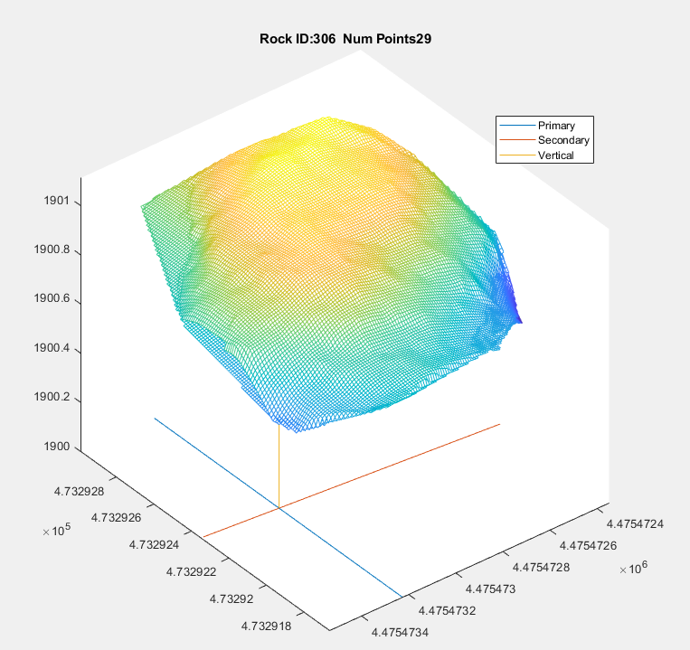

# Conclusion:

The RocKIE algorithm is a powerful analysis tool for Riprap gradation that can significantly improve the workflow of specification validation. Efforts need to be made to increase point cloud densities and ensure that every rock is appropriately surveyed. The major improvement that is required to be made to this process is the segmentation.